K2/Spice
Packaging – There are hundreds of pretty packages this dangerous drug may come in, this is only a few
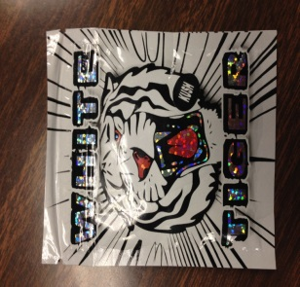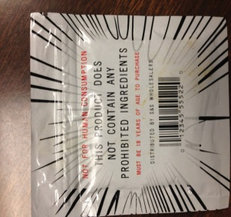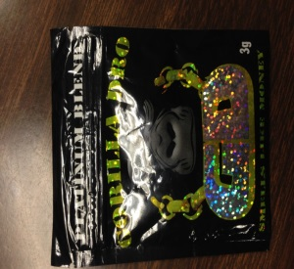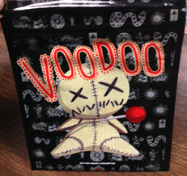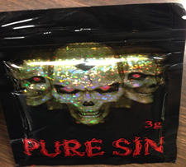
ATTENTION PARENTS AND STUDENTS
K2/Spice is SYNTHETIC CANNABINOIDS they are NOT synthetic marijuana!
K2 and Spice are just a few names for a line of synthetic designer drugs that are intended to mimic THC (the main active ingredient in marijuana). These designer synthetic drugs are from the synthetic cannabinoid (SC) class of drugs that are often marketed and sold under the guise of “herbal incense” or “potpourri”. K2 (SC) is NOT SYNTHETIC MARIJUANA! K2 is NOT organic and there is nothing natural about K2. Synthetic Cannabinoids are a group of chemical compounds that are created in a laboratory. The chemical compound is then sprayed on organic matter and smoked in a fashion similar to marijuana.
What do Synthetic Cannabinoids look like:
The chemical compounds are generally found in bulk powder, and are then dissolved in solvents such as acetone, before being applied to dry plant material. After local distributors apply the drug to the dry plant material, they package it in a variety of sizes and styles of foil type packages and market it to the end user. Some of the marketed names include: Spice, K2, Blaze, RedX Dawn, Paradise Demon, Black Magic, Scooby Snax, Tigerz and Mr. Nice Guy.
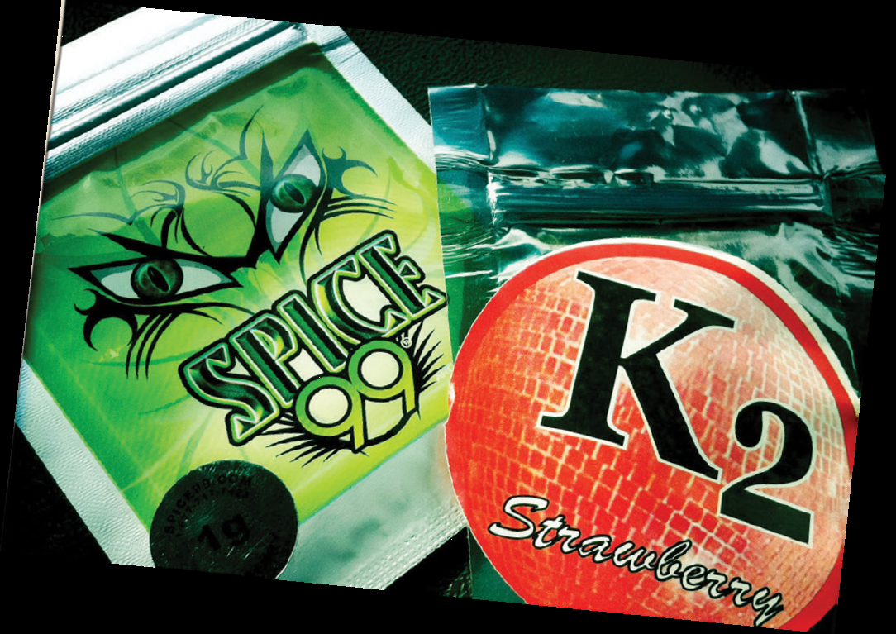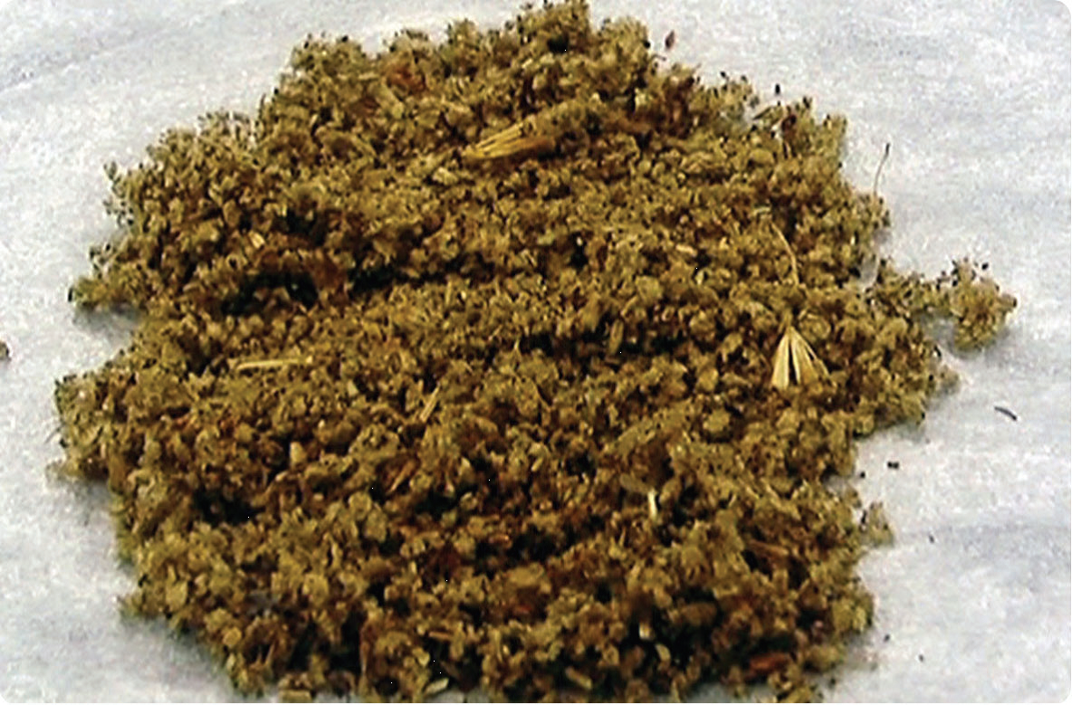
Symptoms of Use:
The symptoms of use vary widely from person to person for a variety of reason. First, the chemical compounds can vary greatly depending on the manufacturer of the product. Second, an individual’s response to the ingestion of the chemicals can also vary greatly depending on a variety of physiological and biological factors. Some possible symptoms can include but are not limited to:
- Acute psychotic episodes
- Intense hallucinations
- Severe agitation
- Anxiety
- Disorganized thoughts
- Paranoid delusions
- Unexplained violence
- Elevated heart rate
- Elevated blood pressure
- Unconsciousness
- Tremors
- Seizures
- Vomiting
- Numbness and tingling
- DEATH
Synthetic Cannabinoids are POISONOUS CHEMICALS!
Overdose Risks:
- Overdose deaths have been attributed to abuse of synthetic cannabinoids, including death by heart attack.
- Acute kidney injury requiring hospitalization and dialysis have also been reported in patients having smoked synthetic cannabinoids.
Manufacturing and Distribution:
- The majority of synthetic cannabinoids are manufactured in Asia without manufacturing requirements or quality control standards. The bulk products are smuggled into the United States as misbranded imports.
- End users purchase the synthetic cannabinoids in convenience stores, head shops, gas stations and via the internet from both domestics and international sources.
Who to call for help:
If you encounter a product that you believe might be synthetic cannabinoids, contact the Dallas Police Department Narcotics Division at (214) 671-3120.
If you encounter a product that you believe might be synthetic cannabinoids at your school, contact the Dallas ISD Police Department at (214) 932-5627.
If you have any information about drug dealers or drug locations, contact the Dallas Police Department Narcotics Division at (214) 671-3120.

